

**DATABASE MANAGEMENT SYSTEM(CBS-1007)**

**SLOT: L33+34**

**LAB ASSESSMENT -4**

**NAME**-GAURAV SINGH

**REG NO.-** 19BBS0026

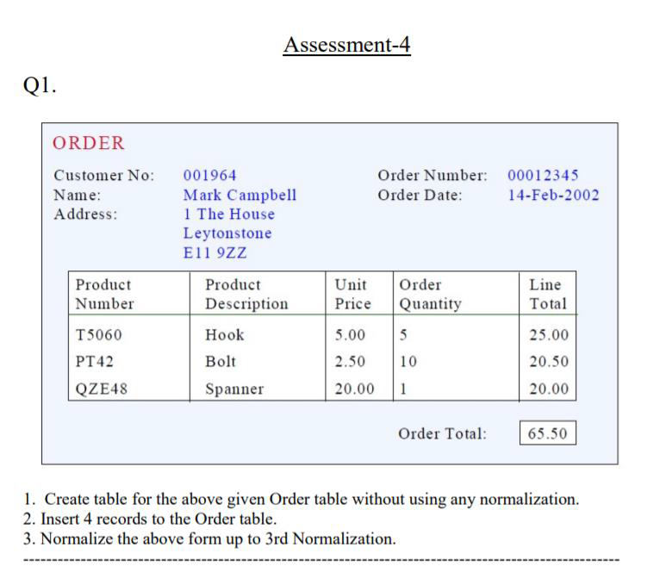

**1. Create table for the above given Order table without using any normalization.**

**Query:**

* Create table Bill

(Cust_no int,cust_name varchar(20),

cust_address varchar(20),order_no int,

order_date date,product_no int,

product_description varchar(20), unit_price int,

order_quantity int,line_total int,

order_total int);

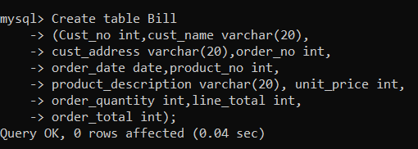

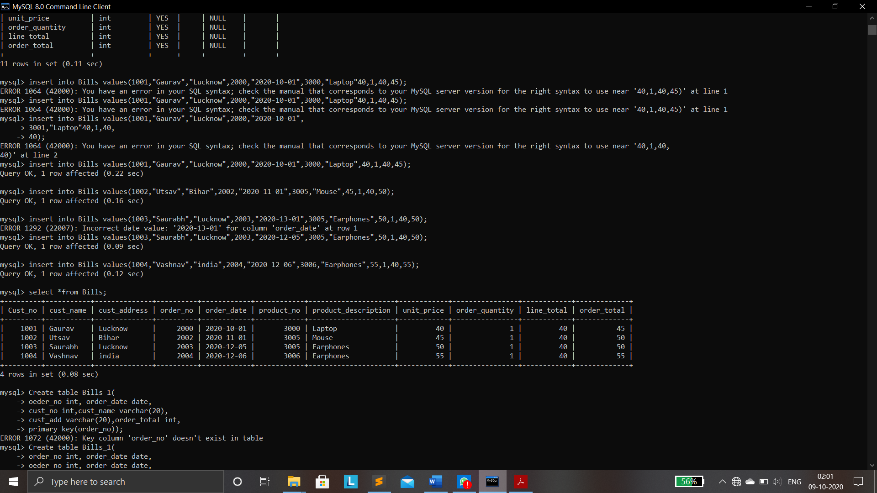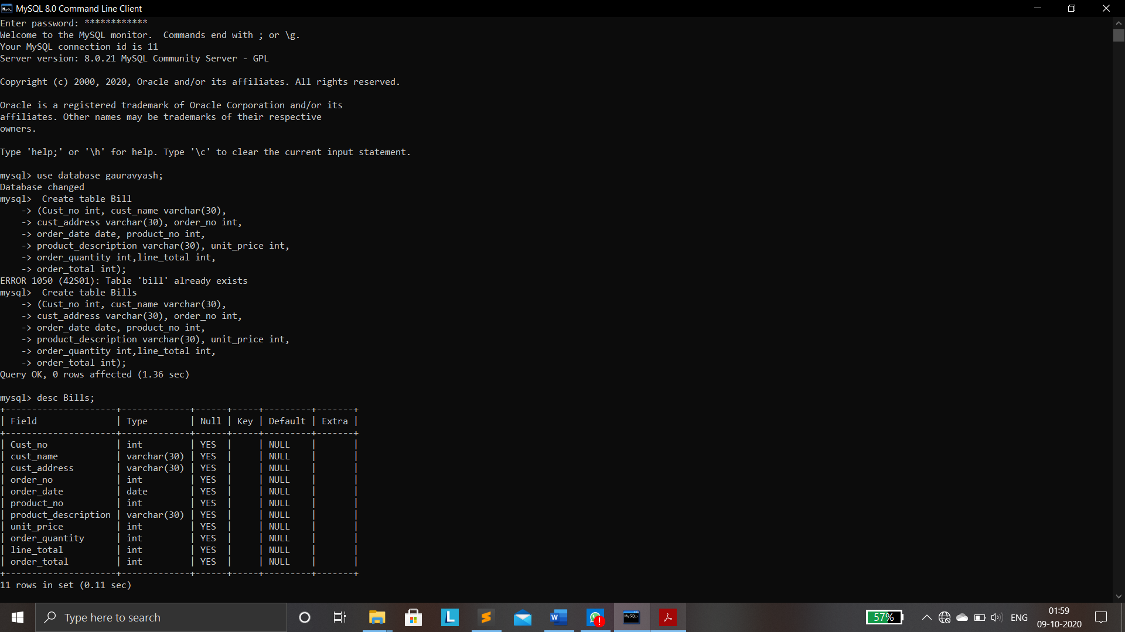

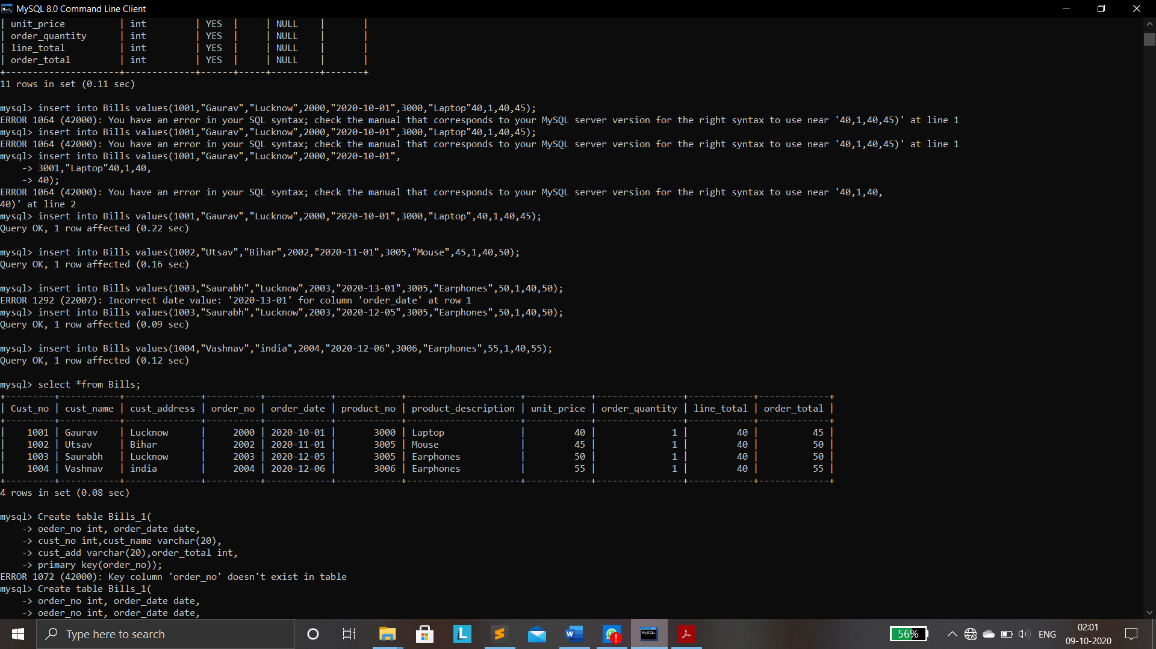**UN NORMALISED TALBE:**

**1 NF:**

* Create table Bill_1(

order_no int,order_date date,

cust_no int,cust_name varchar(20),

cust_add varchar(20),order_total int,

primary key(order_no));

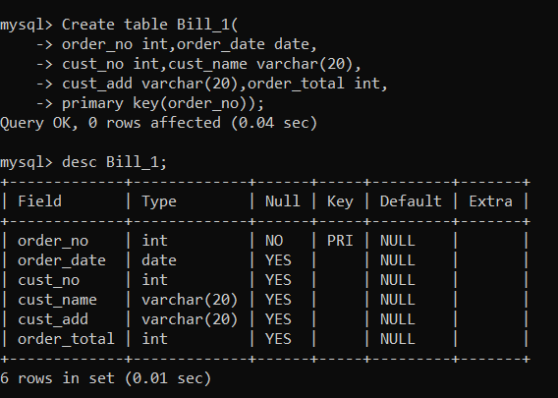

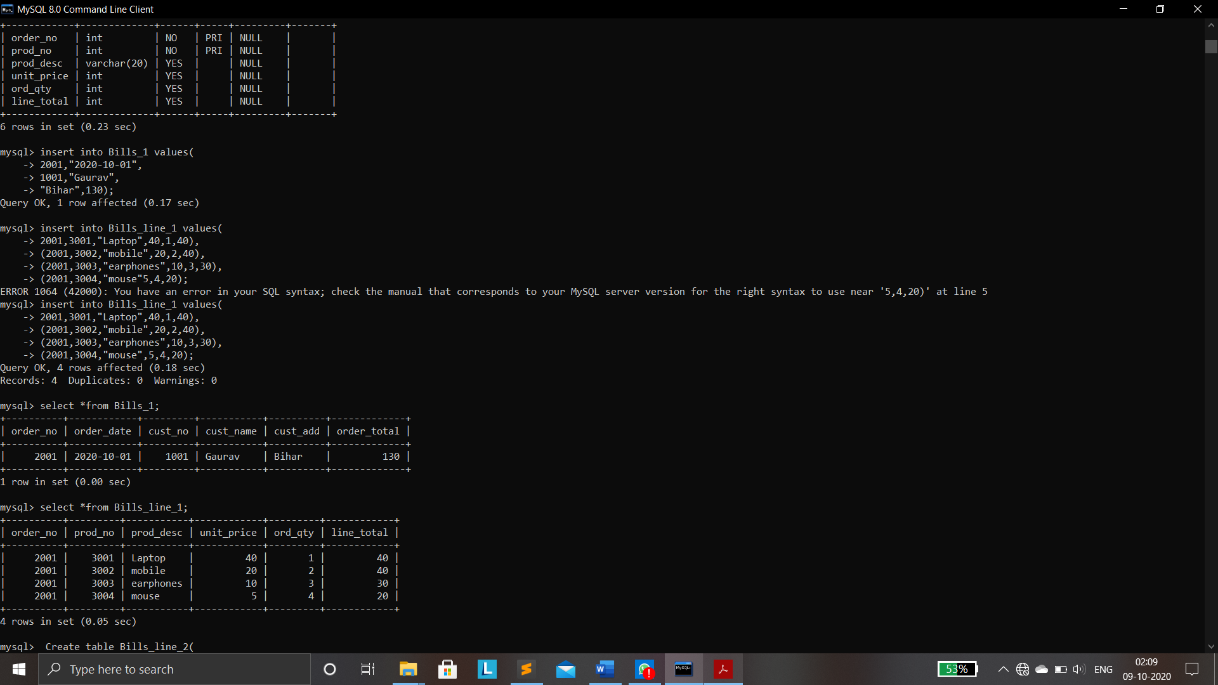

* Create table Bill_line_1(

Order_no int,prod_no int,

Prod_desc varchar(20),unit_price int,

Ord_qty int,line_total int,

Primary key(order_no,prod_no));

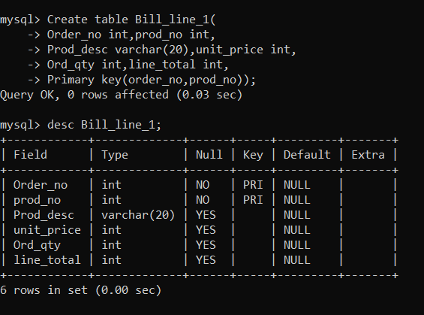



**TABLES AFTER 1F:**



**1NF TO 2NF:**

* Create table bill_line_2(

order_no int ,prod_no int ,

ord_qty int,line_total int,

primary key(order_no,prod_no));

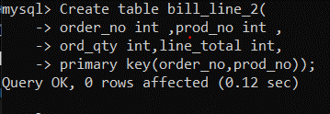

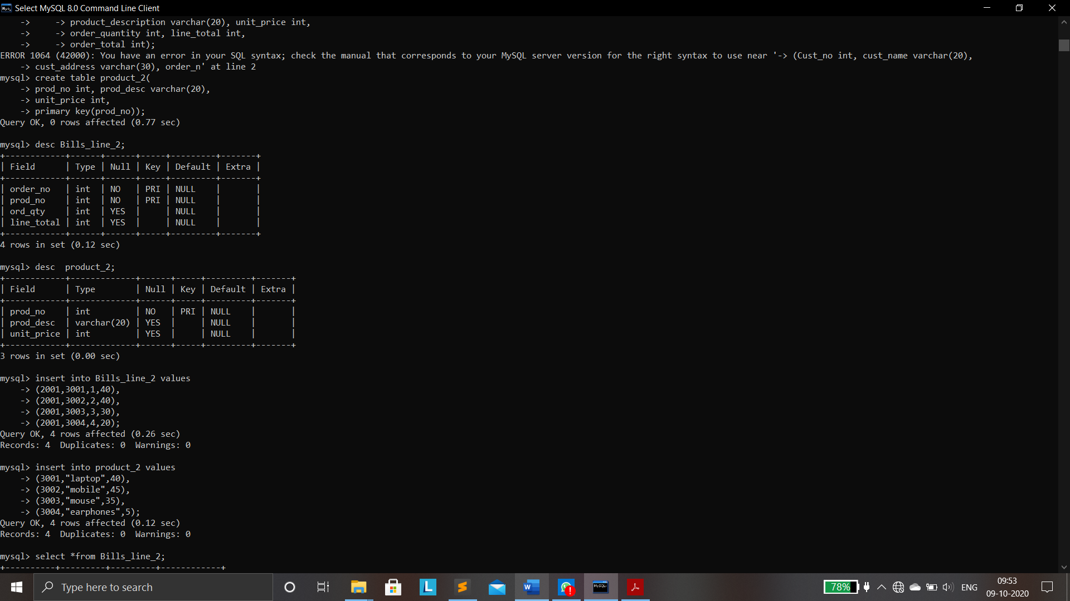



* Create table product_2(

prod_no int,prod_desc varchar(20),

unit_price int,primary key(prod_no));

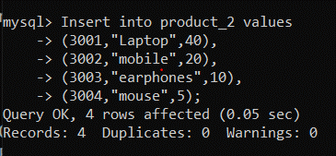





**TABLES AFTER 2NF:**

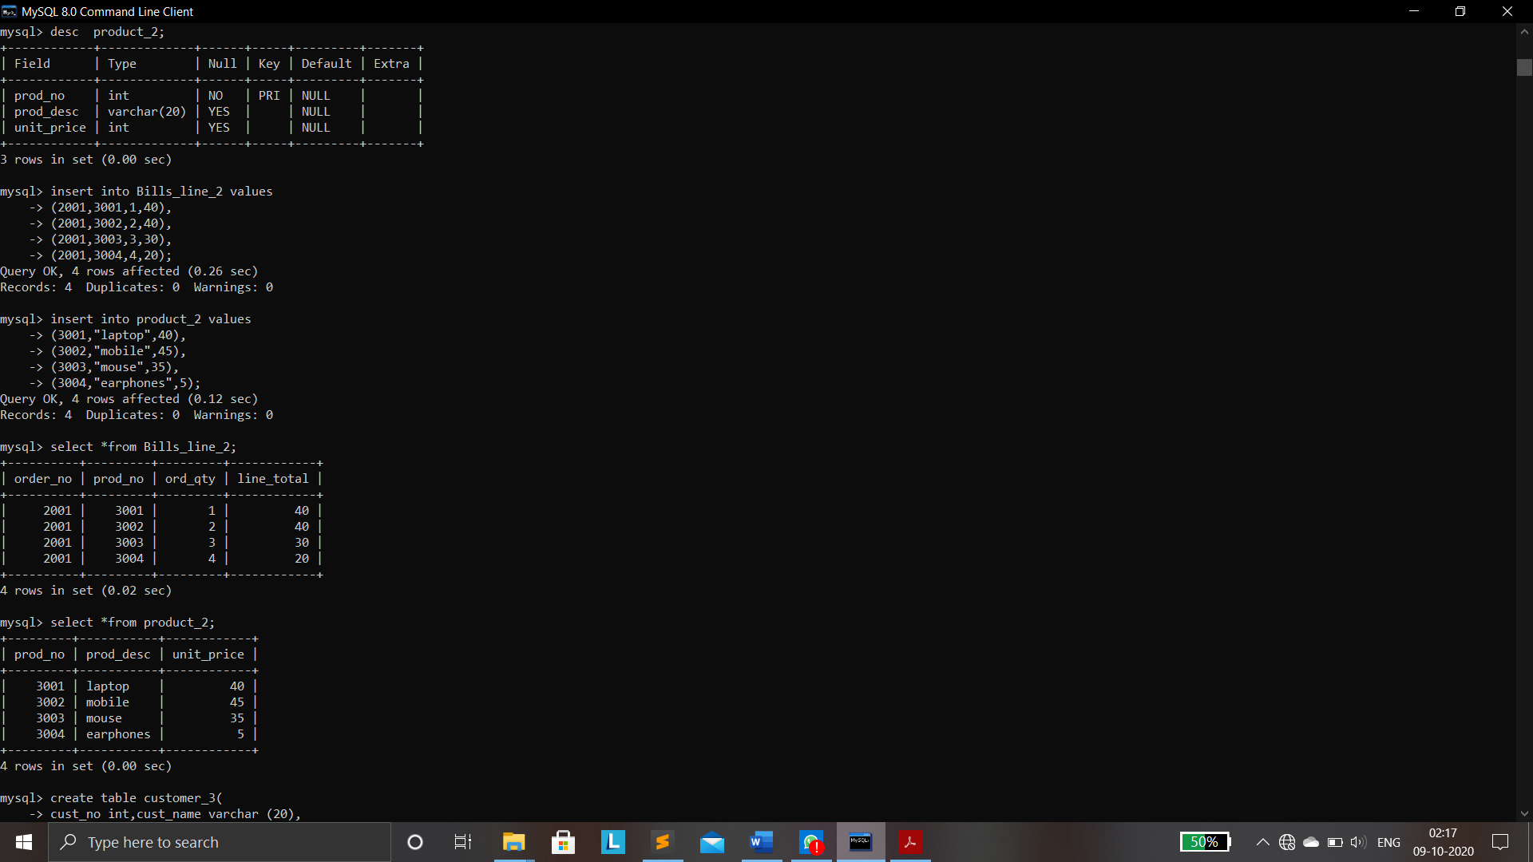

**2NF TO 3NF:**

* create table customer_3(

cust_no int, cust_name varchar(20),

cust_address varchar(50),

primary key(cust_no));

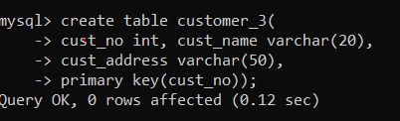

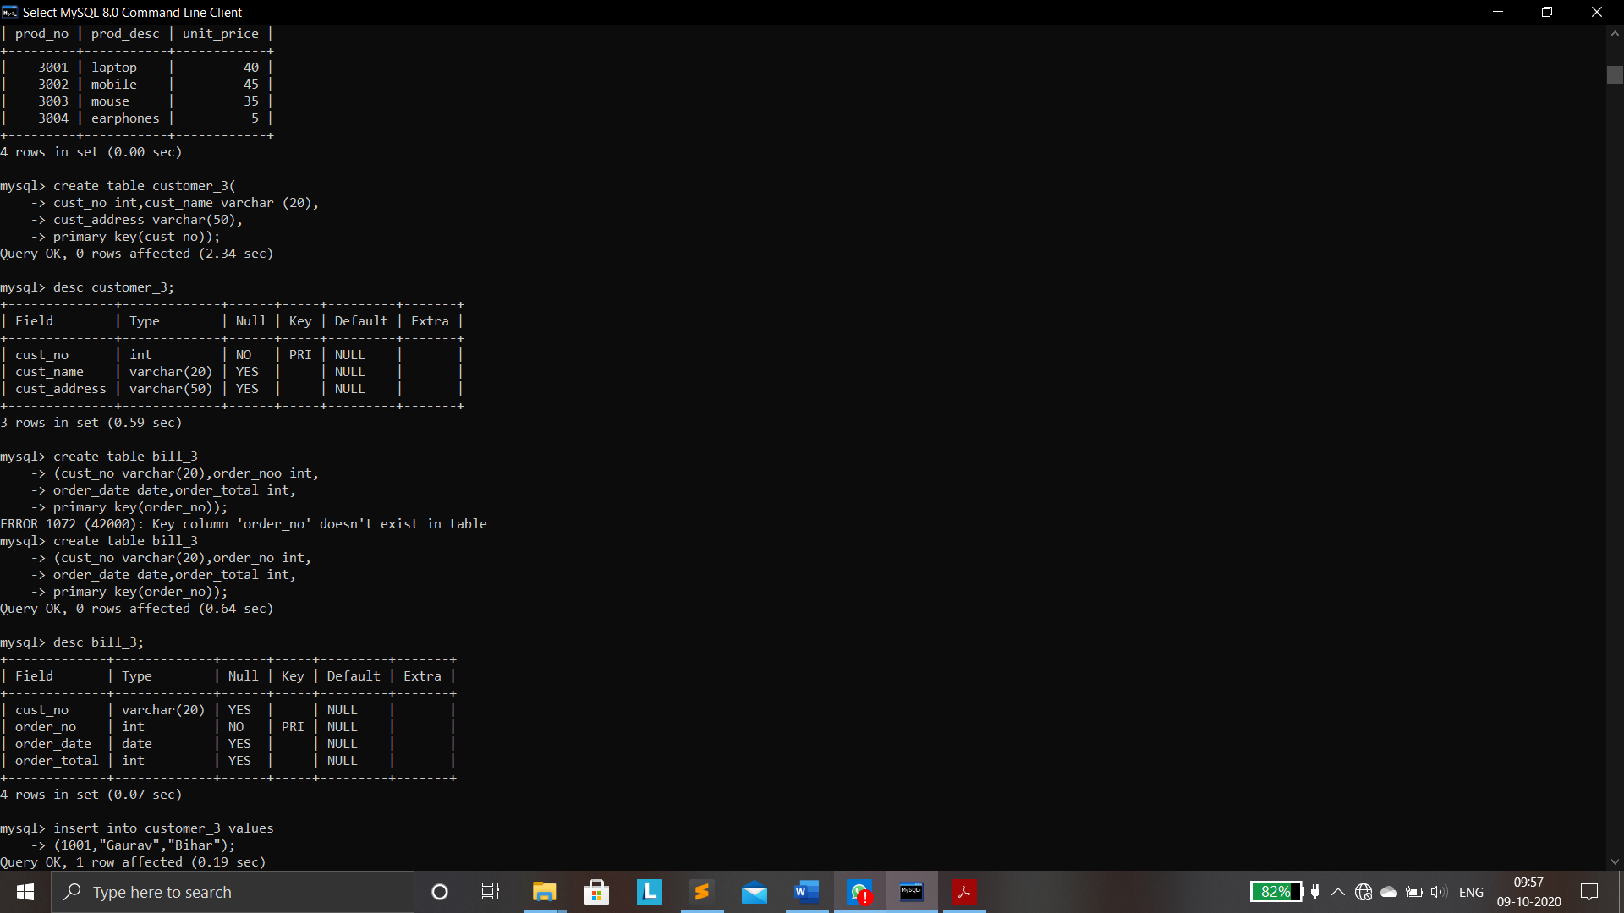

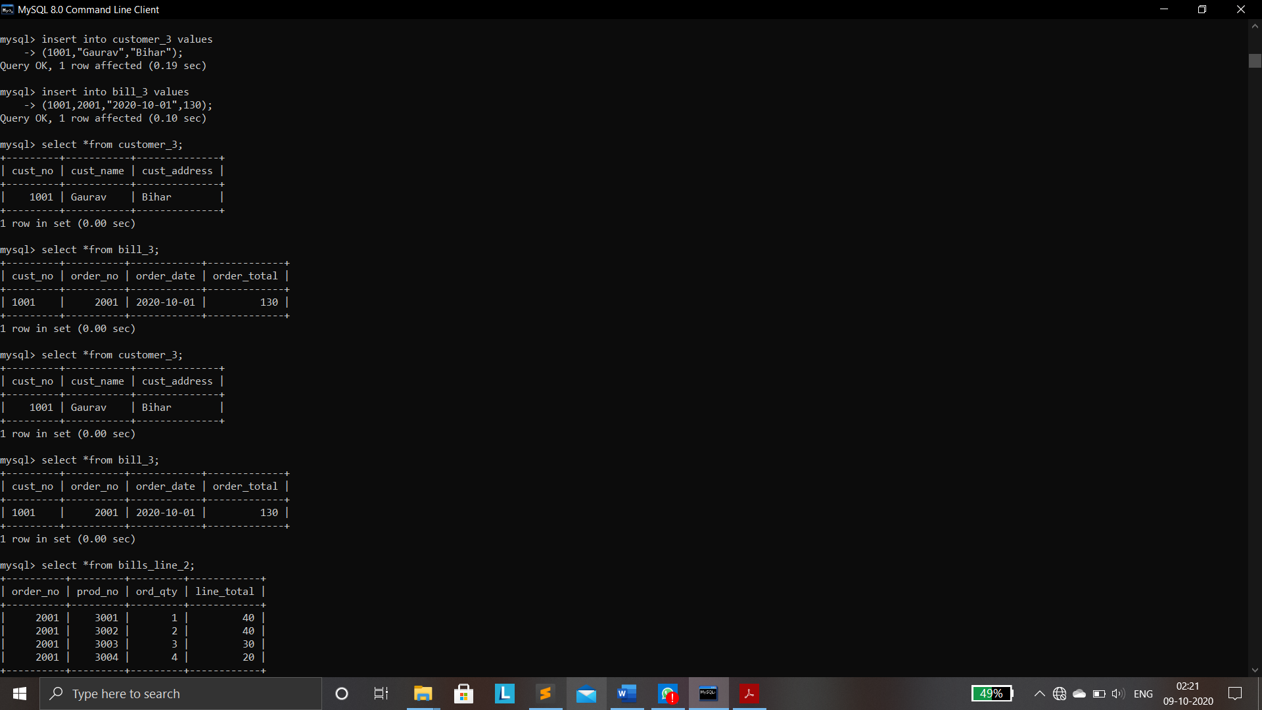

* Create table bill_3

(cust_no varchar(20),Order_no int,

Order_date DATE,order_total int,

Primary key(order_no));

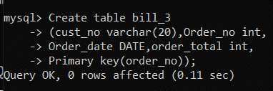





**TABLES AFTER 3NF:**



**FINAL TABLES AFTER NORMALIZATION:**

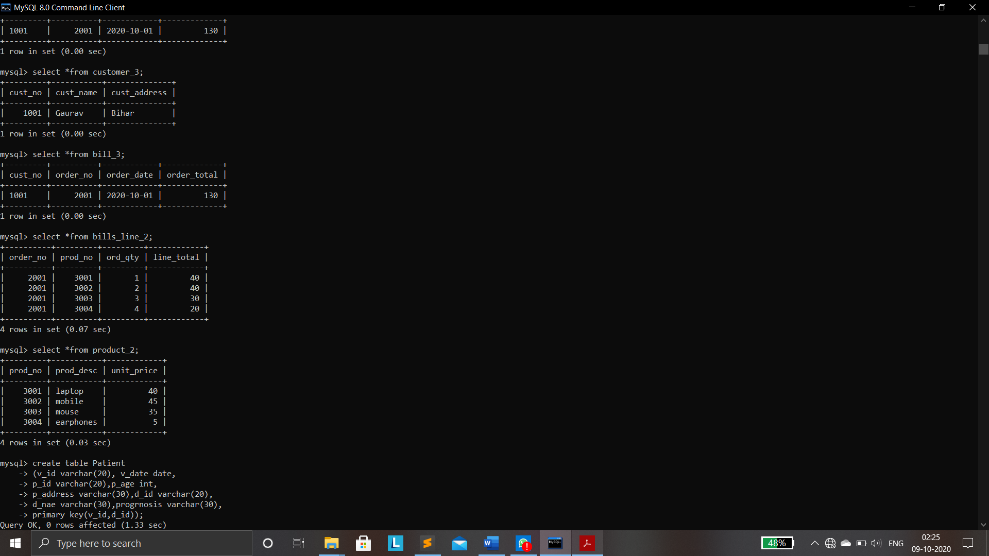



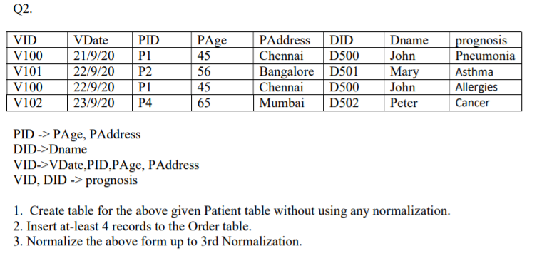

**1NF:**

* Create table Patient

(V_ID varchar(20),V_Date date,

P_ID varchar(20),P_Age int,

P_Address varchar(30),D_ID varchar(20),

D_Name varchar(30),Progrnosis varchar(30),

Primary key(V_ID,D_ID));

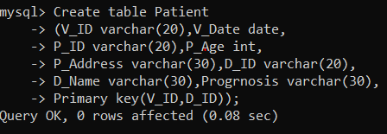

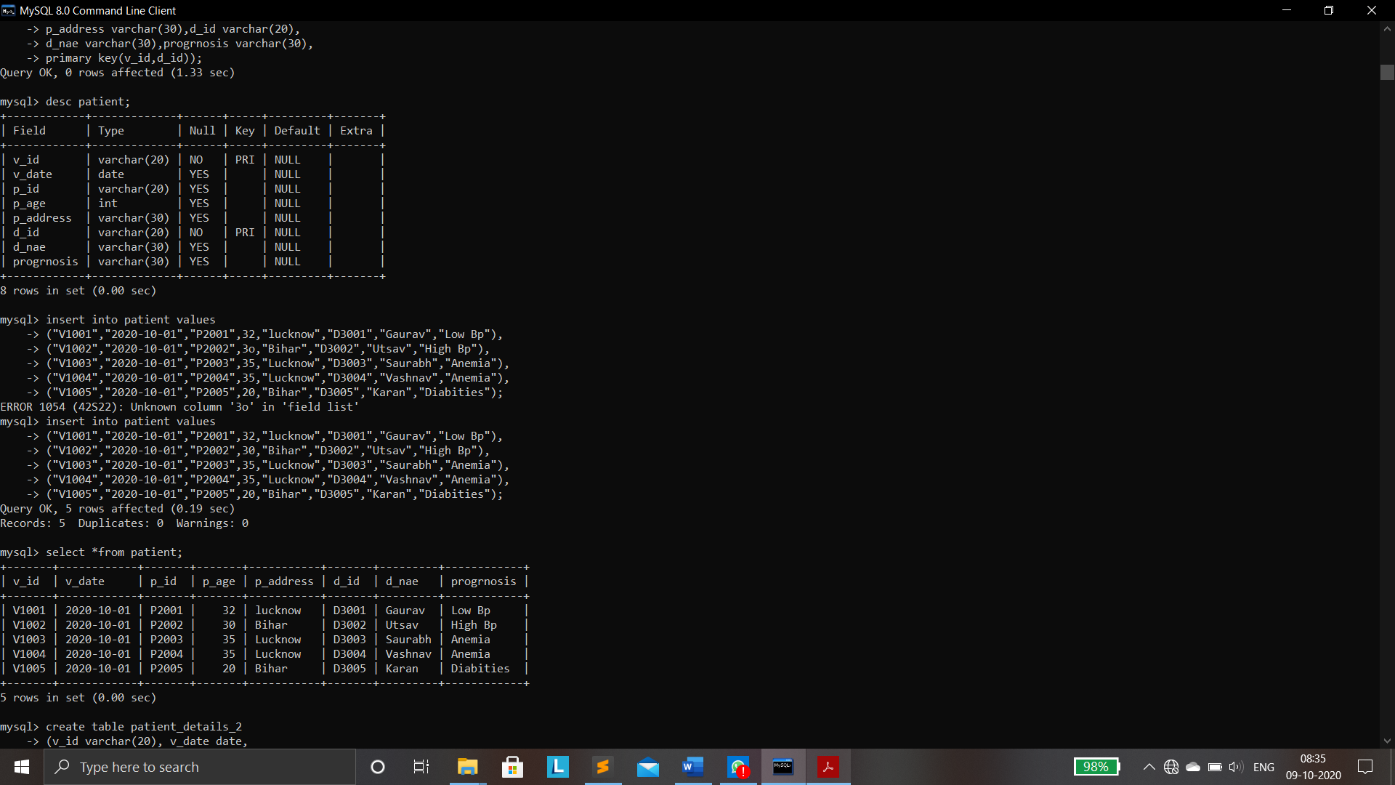



**TABLE AFTER 1NF:**

**2NF:**

* Create table Patient_Details_2

(V_ID Varchar(20),V_Date DATE,

P_ID Varchar(20),P_Age int,

P_Address VARCHAR(100),Primary Key(V_ID));

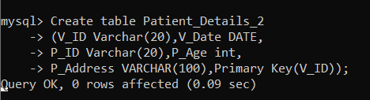

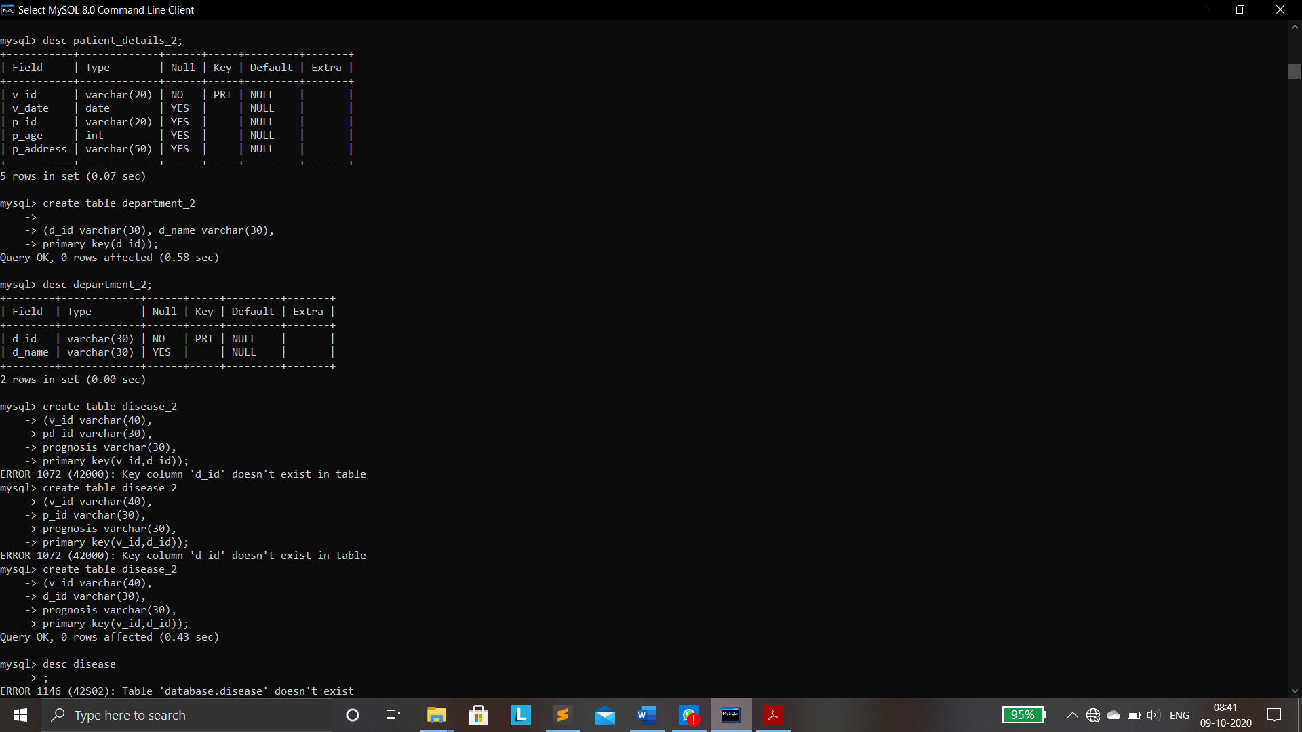

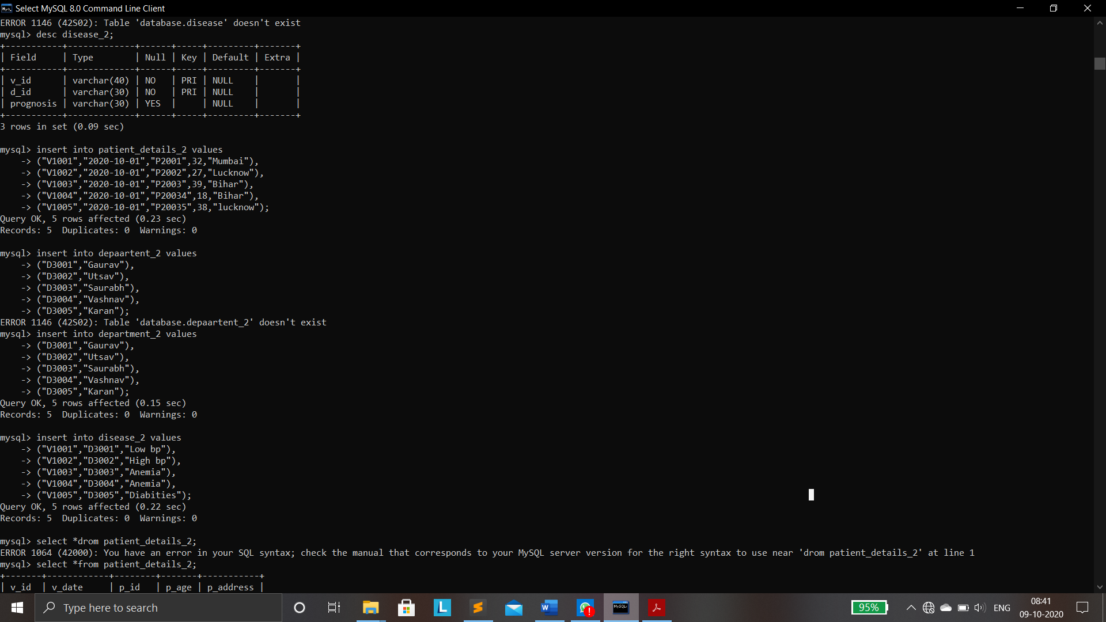

* Create table Department_2

(D_ID varchar(40),D_Name Varchar(40),

Primary key (D_ID));

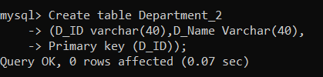





* Create table Disease_2

(V_ID Varchar(40),D_ID varchar(40),

Prognosis varchar(40),Primary key(V_ID,D_ID))

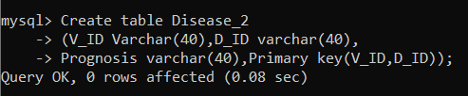





**TABLES AFTER 2NF:**

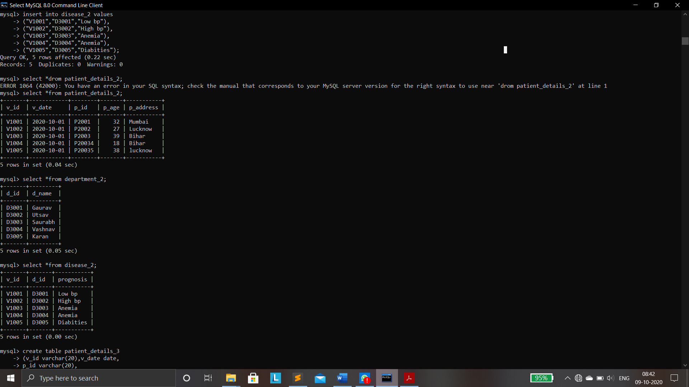

**3NF:**

* Create table Patient_Details_3

(V_ID varchar(20),V_Date DATE,

P_ID Varchar(20),Primary key(V_ID));

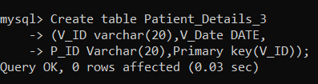

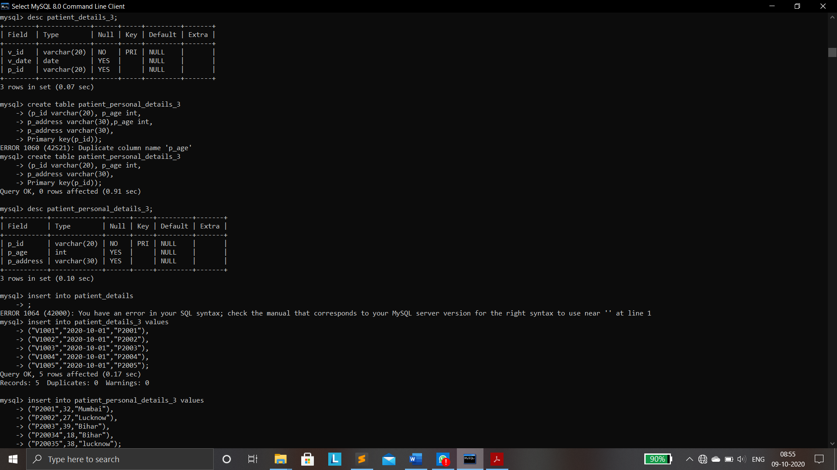



* Create table Patient_Personal_Details_3

(P_ID varchar(20),P_Age int,

P_Address varchar(30),Primary key(P_ID));

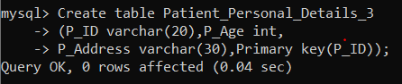



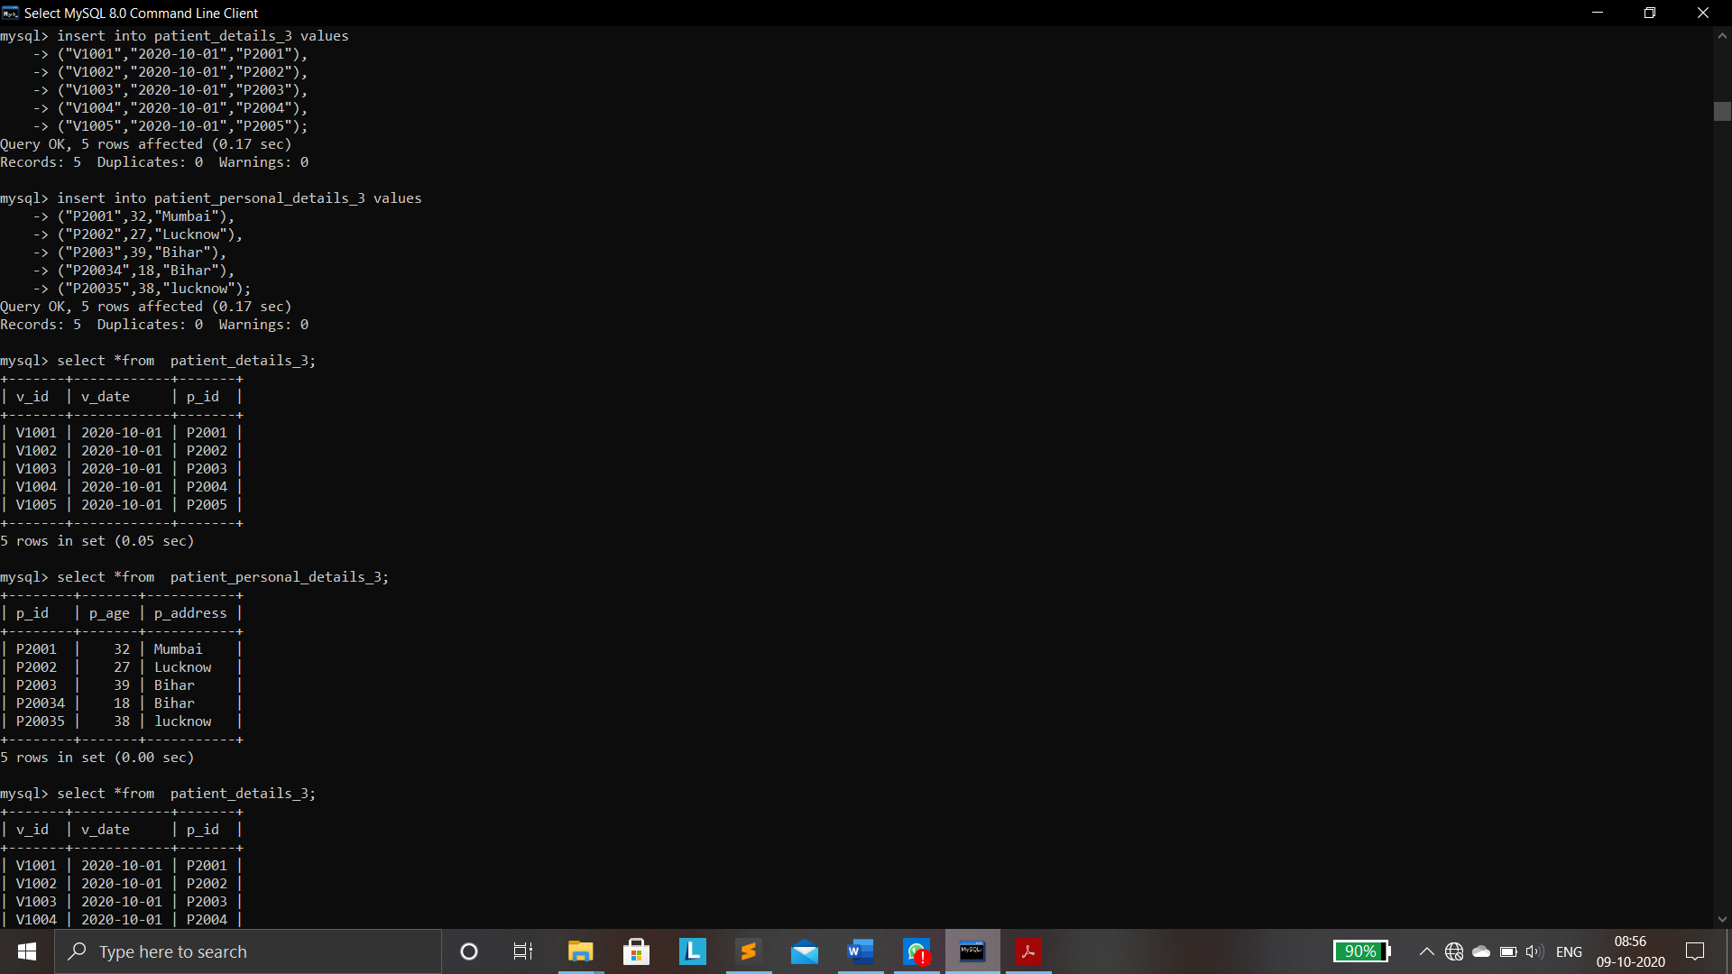

**TABLES AFTER 3NF:**   


**FINAL TABLES AFTER NORMALISATION:**







**Create table Invoice (**

**Hospital_Name varchar(20),**

**Invoice_ID varchar(20),**

**Patient_Name varchar(20),**

**Patient_Address varchar(30),**

**Invoice_Date Date,**

**PET_Name varchar(20),**

**PET_Procedure varchar(30),**

**PET_Amount int,**

**Invoice_Total_tax int,**

**Invoice_Total int);**



**Insert into Invoice Values**

**(“Apollo Hospital”,”I1001”,“Mr.Rohan”,”FlatNo.402,Hyd”, “2020-10-02”, ”Rocky”,”Rabies Vaccination”,700,396,2596),**

**(“Apollo Hospital”,”I1001”,“Mr.Rohan”,”FlatNo.402,Hyd”, “2020-10-02”, ”Billy”,”Distempes Vaccination”,600, 396, 2596),**

**(“Apollo Hospital”,”I1001”,“Mr.Rohan”,”FlatNo.402,Hyd”, “2020-10-02”, ”Stuart”,”Parovirus Vaccination”,500, 396, 2596),**

**(“Apollo Hospital”,”I1001”,“Mr.Rohan”,”FlatNo.402,Hyd”, “2020-10-02”, ”John”,”Lyme Vaccination”,400, 396, 2596);**



**UNF:**



**UNF TO 1NF:**

Create table Invoice_1(

Invoice_ID varchar(20),

Invoice_Date Date,

Patient_Name varchar(20),

Hopsital_Name varchar(20),

Patient_Address varchar(50),

Invoice_Total_tax int,

Invoice_Total Int,

Primary key(Invoice_ID));



**Create table PET_1(**

**Invoice_ID varchar(20),**

**PET_Name varchar(20),**

**PET_Procedure varchar(50),**

**PET_Amount int,**

**Primary key(PET_Name,Invoice_ID));**



**Insert into Invoice_1 Values**

**(“I1001”, “2020-10-02”, “Mr.Rohan”, “Apollo Hospital”,”FlatNo.402,Hyd”, 396,2596);**



**Insert into PET_1 Values**

**(“I1001”,”Rocky”,”Rabies Vaccination”,700),**

**(“I1001”,”Billy”,”Distempes Vaccination”,600),**

**(“I1001”,”Stuart”,”Parovirus Vaccination”,500),**

**(“I1001”,”John”,”Lyme Vaccination”,400);**



**TABLES AFTER 1NF**



**1NF TO 2NF:**

Create table PET_2(

Invoice_ID varchar(20),

PET_Name varchar(20),

PET_Procedure varchar(30),

Primary Key(Invoice_ID,PET_Name,PET_Procedure)

);



**Create table PET_Procedure_2(**

**PET_Procedure varchar(30),**

**PET_Amount int,**

**Primary Key(PET_Procedure)**

**);**



**Insert into PET_2 Values**

**(“I1001”,”Rocky”,”Rabies Vaccination”),**

**(“I1001”,”Billy”,”Distempes Vaccination”),**

**(“I1001”,”Stuart”,” Parovirus Vaccination”),**

**(“I1001”,”John”, “Lyme Vaccination”);**



**Insert into PET_Procedure_2 Values**

**(”Rabies Vaccination”,700),**

**(“Distempes Vaccination”,600),**

**(“Parovirus Vaccination”,500),**

**(“Lyme Vaccination”,400);**



**TABLES AFTER 2NF:**



**2NF TO 3NF:**

Create table Invoice_3(

Invoice_ID varchar(20),

Invoice_Date Date,

Hopsital_Name varchar(20),

Invoice_Total_tax int,

Invoice_Total Int,

Primary key(Invoice_ID));



**Create table Patient_3(**

**Invoice_ID varchar(20),**

**Patient_Name varchar(20),**

**Patient_Address varchar(50),**

**Primary key(Invoice_ID,Patient_Name)**

**);**



**Insert into Invoice_3 Values**

**(“I1001”, “2020-10-02”, “Apollo Hospital”, 396,2596);**



**Insert into Patient_3 Values**

**(“I1001”,“Mr.Rohan”,”FlatNo.402,Hyd”);**

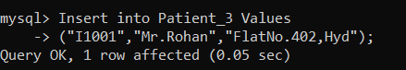

**TABLES AFTER3NF:**



**FINAL TABLES:**





**Create table Purchase(**

**Vendor_Company varchar(20),**

**Vendor_Address varchar(30),**

**Vendor_Phone_No int,**

**Vendor_ID varchar(20),**

**Product__No varchar(20),**

**Product_Name varchar(20),**

**Product_Price int,**

**Product_Quantity int,**

**Product_Line_total int,**

**Sub_Total int,**

**Tax int,**

**Shipping int,**

**Discount int,**

**PO_Total int);**



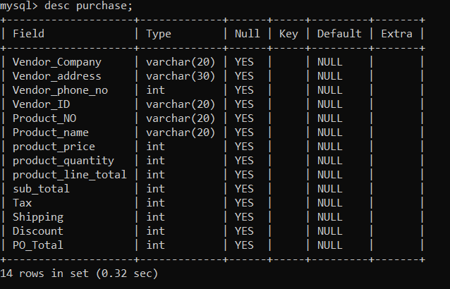

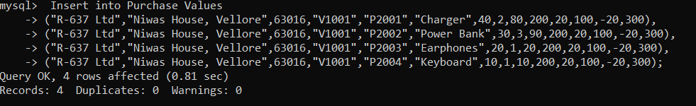

**UNF:**

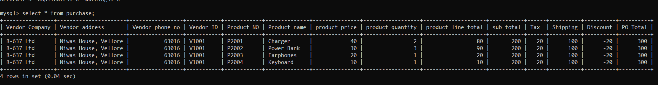

**UNF TO 1NF:**

**Create table Purchase_1(**

**Vendor_Company varchar(20),**

**Vendor_Address varchar(30),**

**Vendor_Phone_No int,**

**Vendor_ID varchar(20),**

**Sub_Total int,**

**Tax int,**

**Shipping int,**

**Discount int,**

**PO_Total int,**

**Primary key (Vendor_ID));**

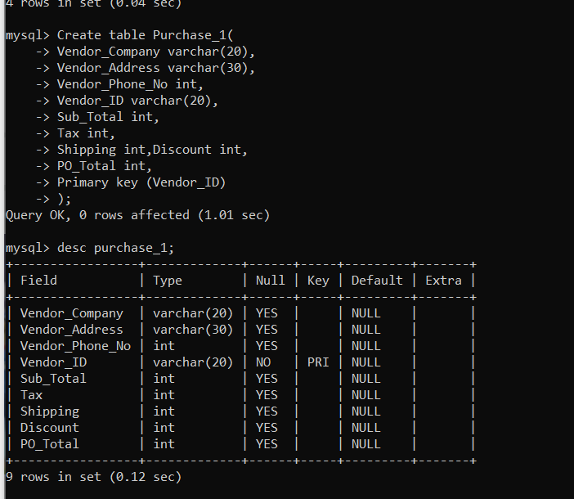

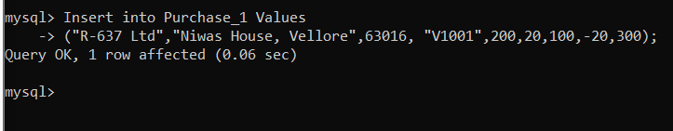

**Create table Product_1(**

**Vendor_ID varchar(20),**

**Product_No varchar(20),**

**Product_Name varchar(20),**

**Product_Price int,**

**Product_Quantity int,**

**Product_Line_total int,**

**Primary key(Vendor_ID,Product_No)**

**);**

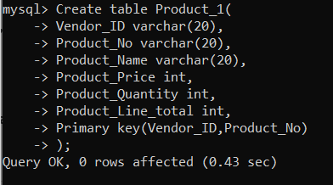

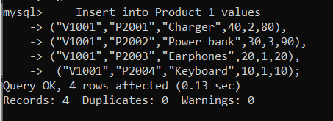

**TABLES AFTER 1NF:**

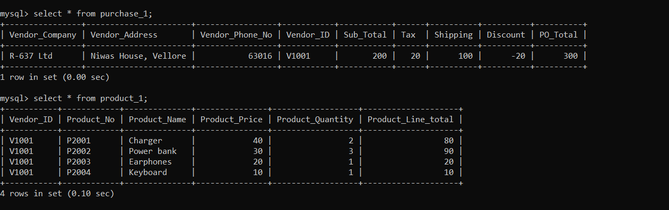

**1NF TO 2NF:**

**Create table Product_2(**

**Vendor_ID varchar(20),**

**Product_No varchar(20),**

**Product_Quantity int,**

**Product_Line_Total int,**

**Primary key(Vendor_ID,Product_No)**

);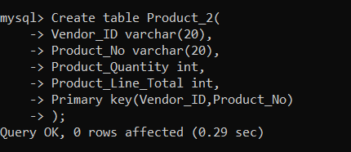

**Create table Product_Cost_2(**

**Product_No varchar(20),**

**Product_Name varchar(20),**

**Product_Price int,**

**Primary key(Product_No));**

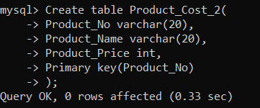

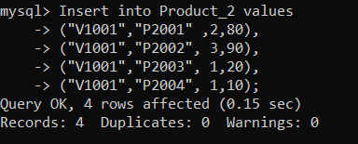

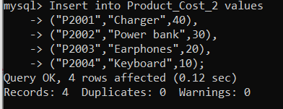

**TABLES AFTER 2NF:** 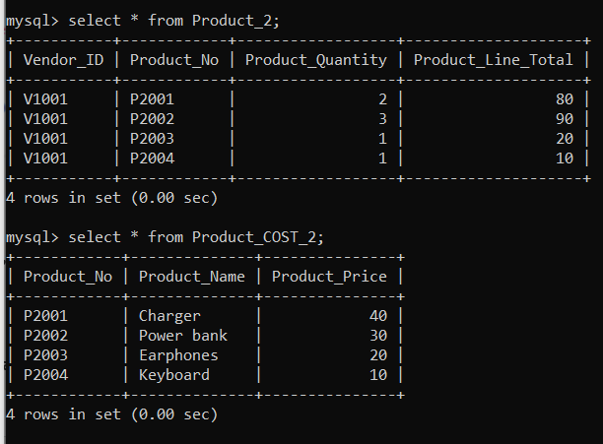

**2NF TO 3NF:**

**Create table Purchase_3(**

**Vendor_ID varchar(20),**

**Sub_Total int,**

**Tax int,**

**Shipping int,**

**Discount int,**

**PO_Total int,**

**Primary key (Vendor_ID)**

**);**

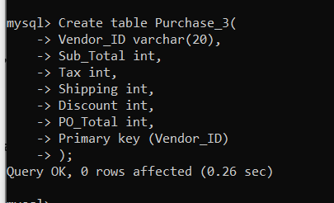

**Create table Vendor_3(**

**Vendor_ID varchar(20),**

**Vendor_Company varchar(20),**

**Vendor_Address varchar(30),**

**Vendor_Phone_No int,**

**Primary key(Vendor_ID)**

**);**

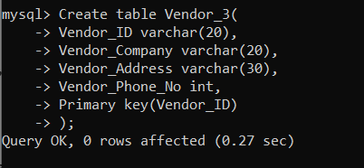

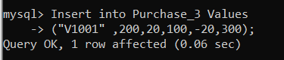

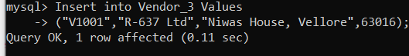

**TABLES AFTER 3NF:**

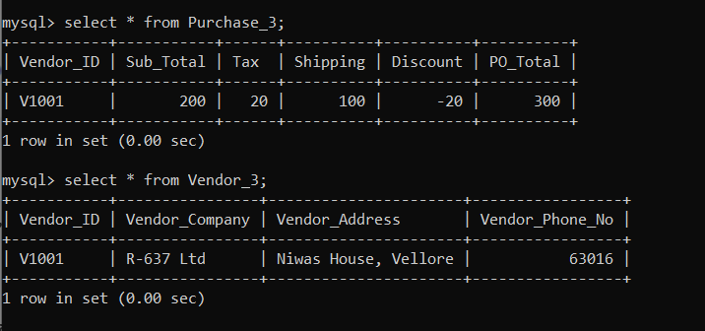

**FINAL TABLES AFTER NORMALISATION:**

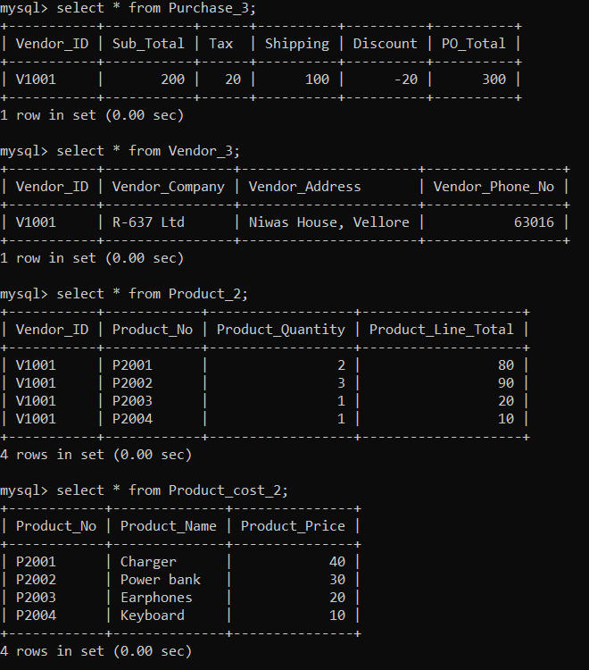

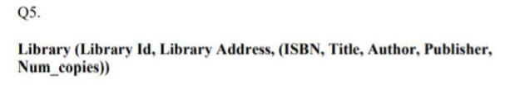

* Create table Library(

Library_ID varchar(20),

Library_Address varchar(20),

ISBN varchar(20),

Title varchar(20),

Author varchar(20),

Publisher varchar(20),

Num_copies int

);

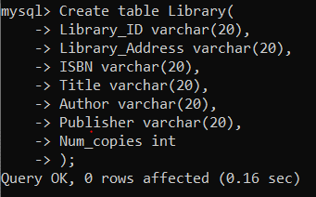

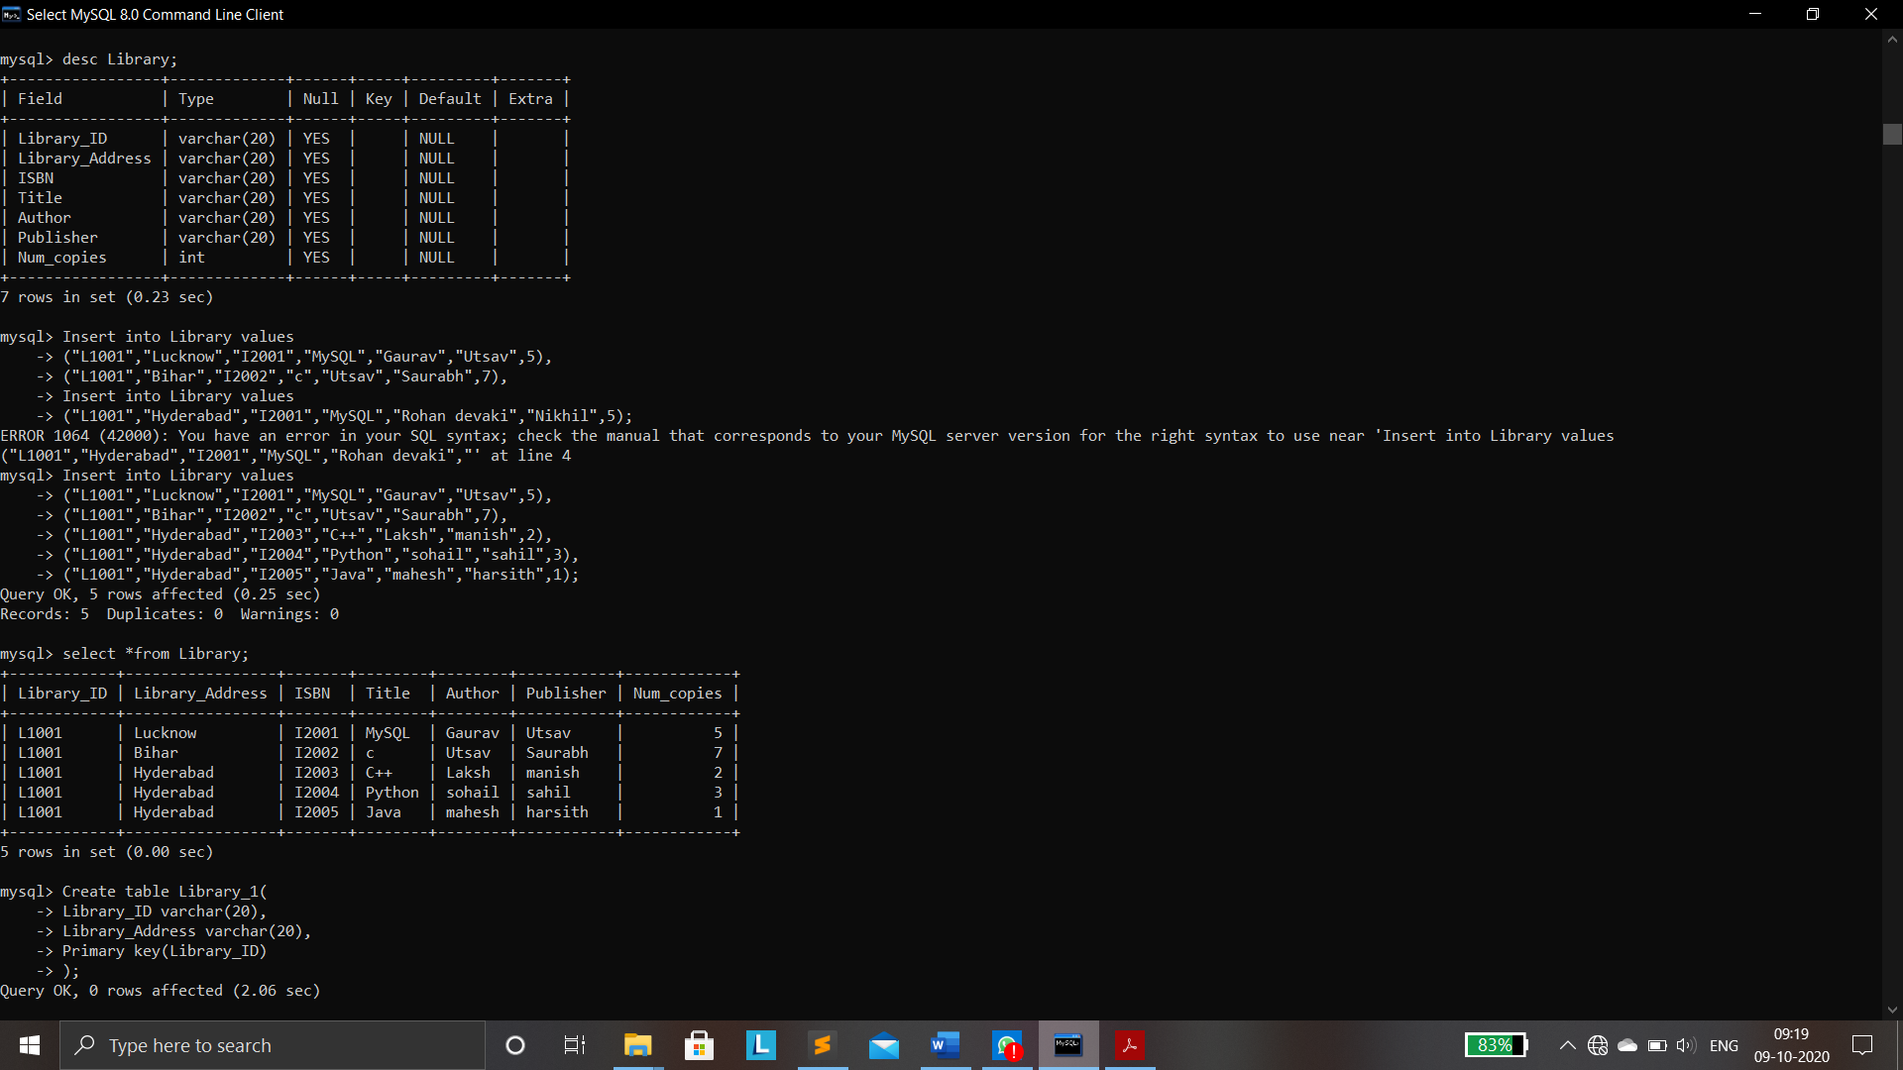



**TABLE AT UNF:**



**UNF TO 1NF:**

* Create table Library_1(

Library_ID varchar(20),

Library_Address varchar(20),

Primary key(Library_ID)

);

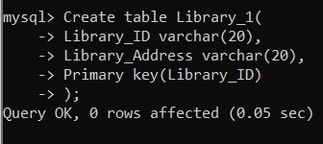

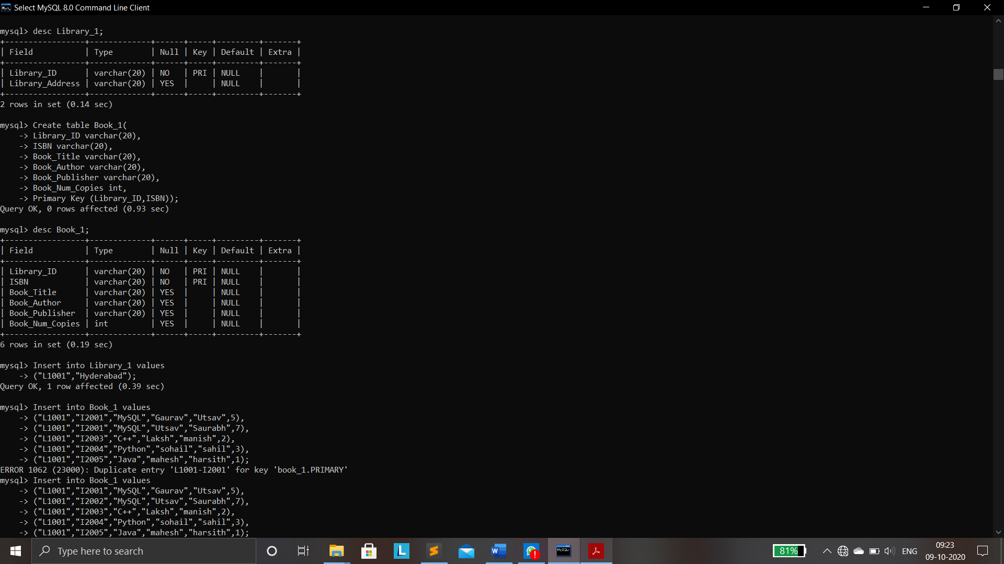



* Create table Book_1(

Library_ID varchar(20),

ISBN varchar(20),

Book_Title varchar(20),

Book_Author varchar(20),

Book_Publisher varchar(20),

Book_Num_Copies int,

Primary Key (Library_ID,ISBN)

);

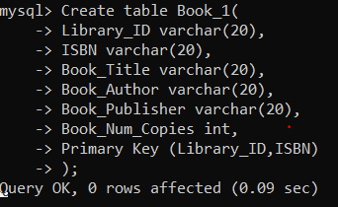



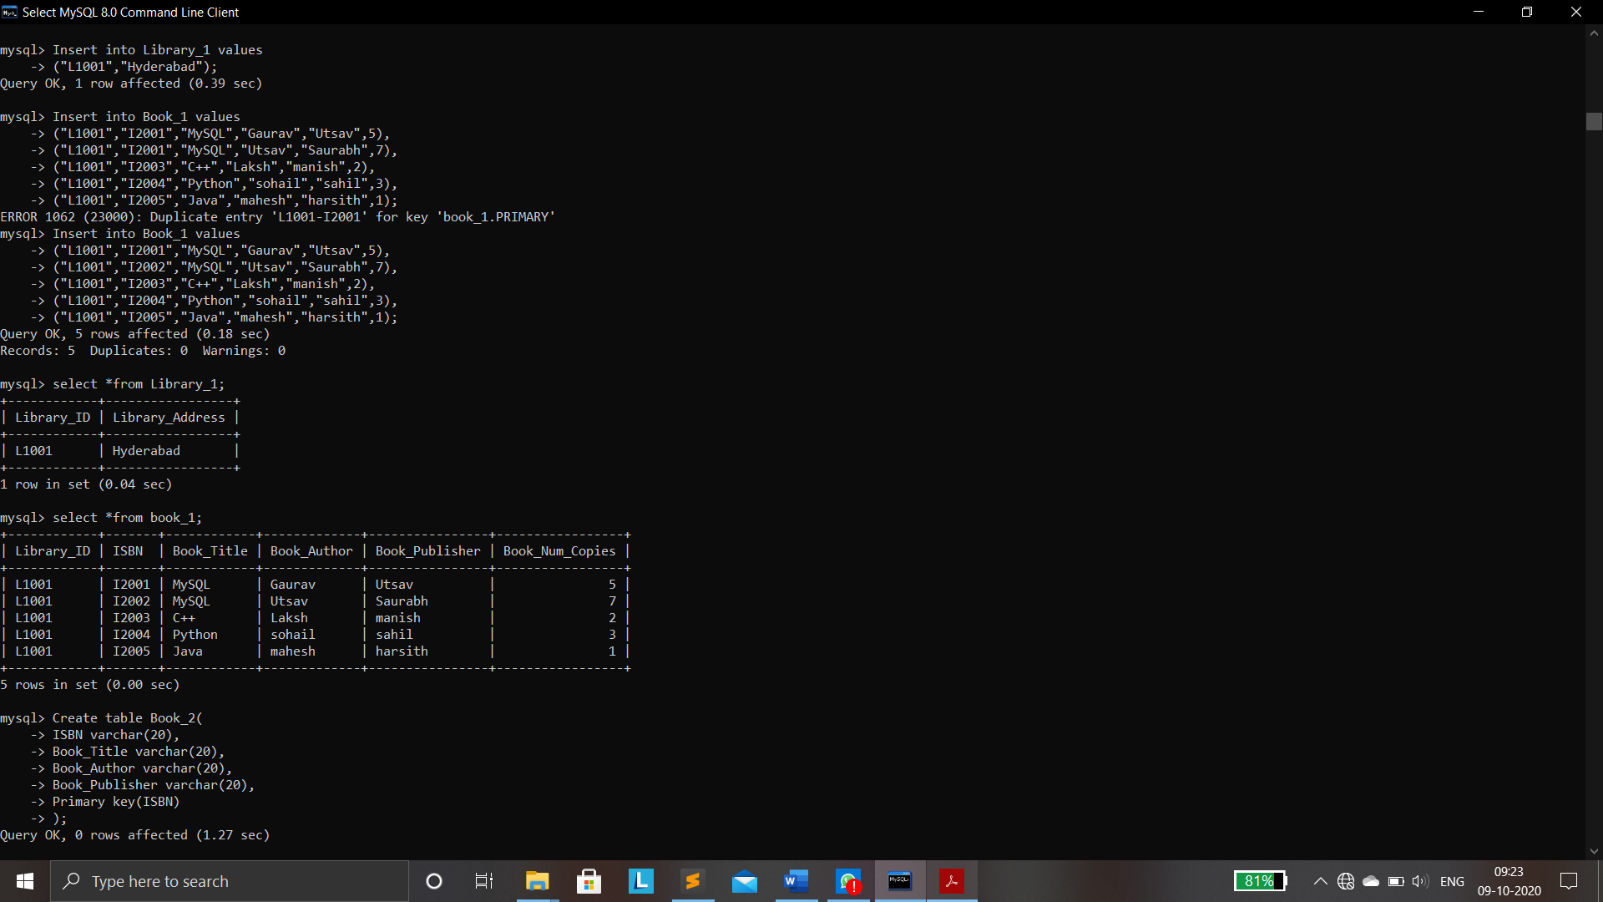

**TABLES AFTER 1NF:**



**1NF TO 2NF:**

* Create table Book_2(

ISBN varchar(20),

Book_Title varchar(20),

Book_Author varchar(20),

Book_Publisher varchar(20),

Primary key(ISBN)

);

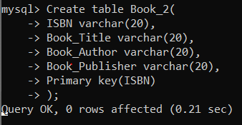

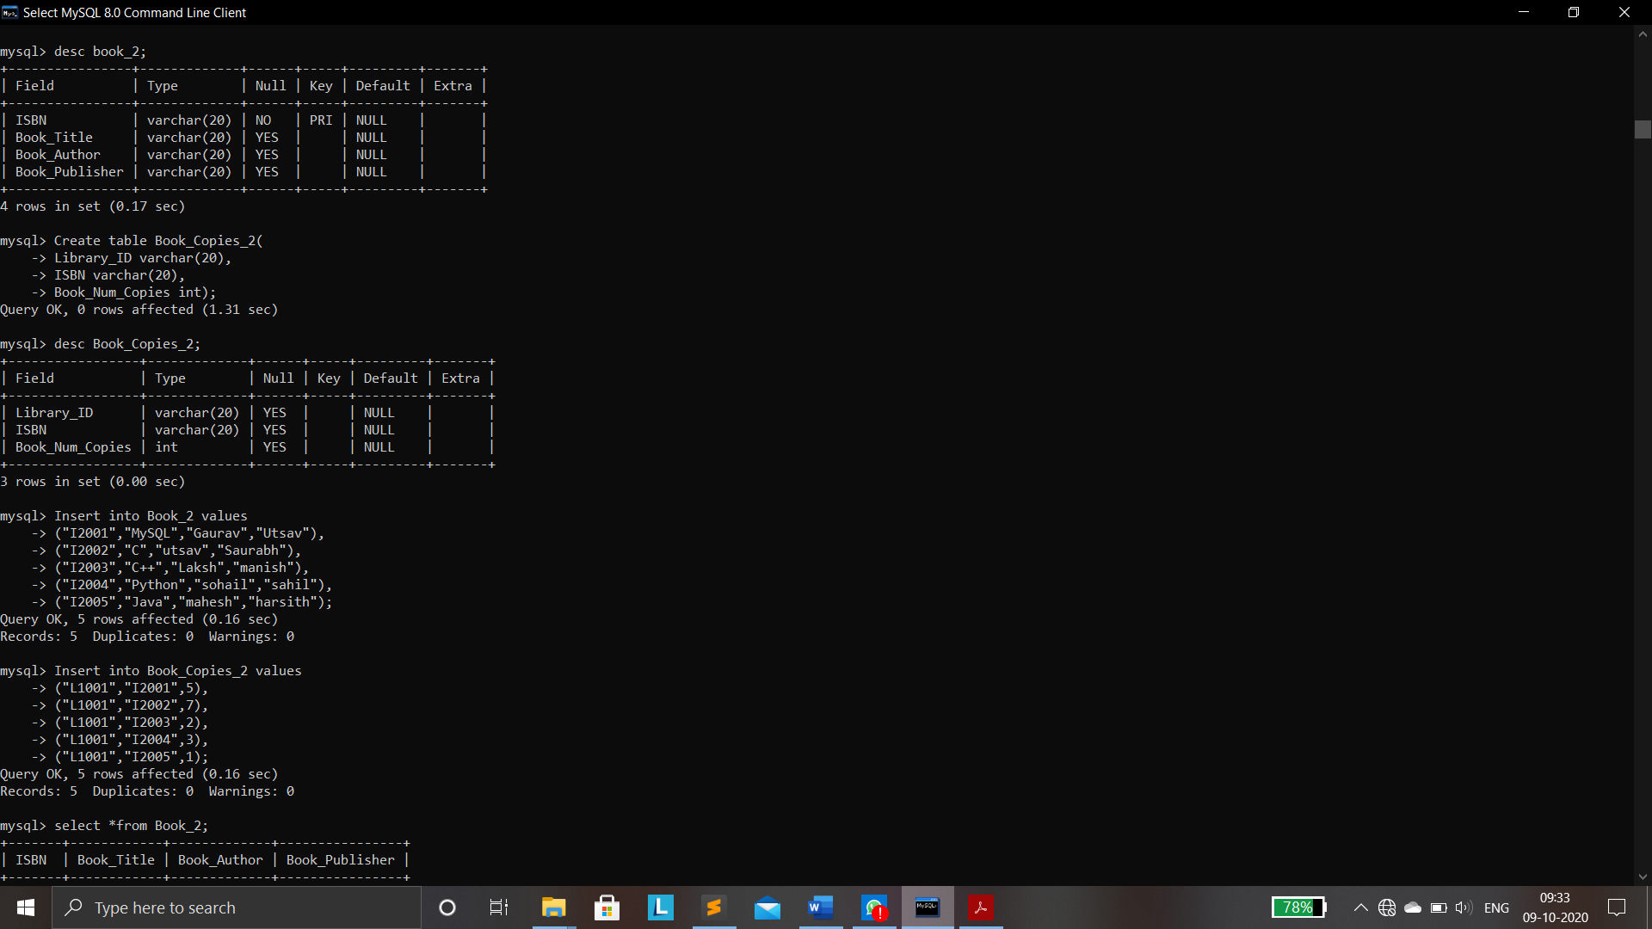



* Create table Book_Copies_2(

Library_ID varchar(20),

ISBN varchar(20),

Book_Num_Copies int

)

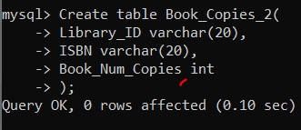





**2NF TO 3NF:**

No transitive dependencies:

**FINAL TABLES AFTER NORMALISATION:**



